🏥 Medical Facility Pitch
Utility-Grade Automation for Hospitals & Medical Cities (8–25+ M SAR)
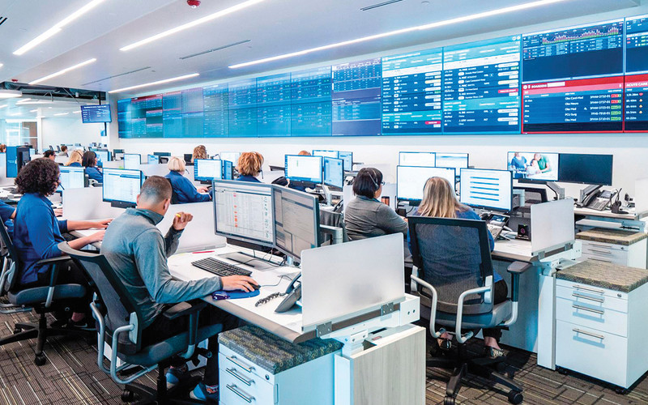
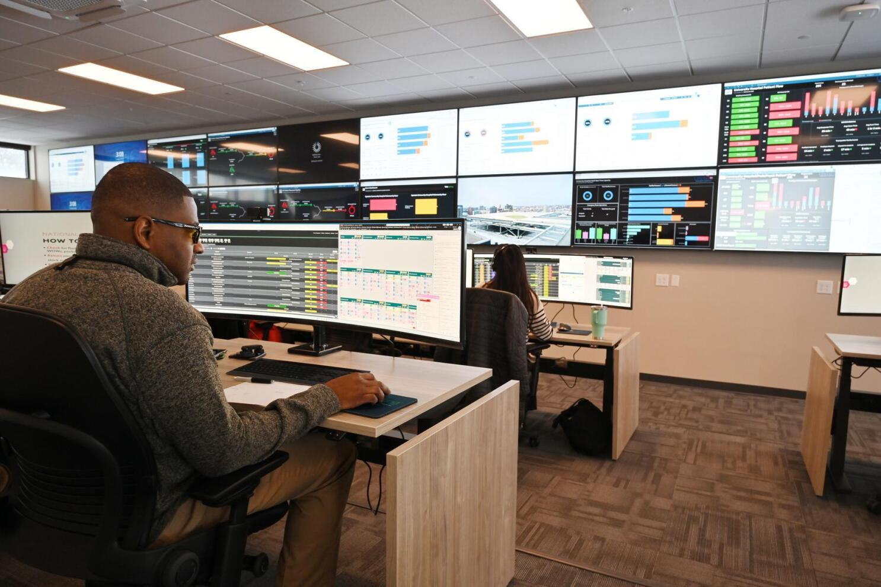
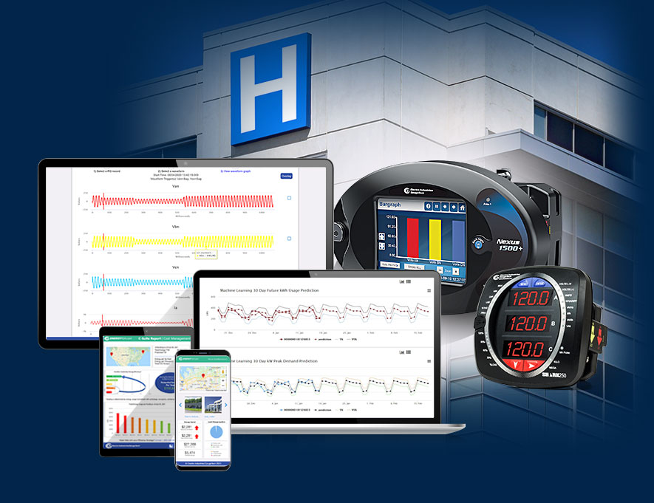
4

Executive Summary
Hospitals and medical campuses operate under zero-tolerance-for-failure conditions. Power interruptions, HVAC instability, alarm floods, or uncoordinated responses directly impact patient safety, clinical outcomes, and regulatory compliance.
Mohammed Al-Ojaimi Energy Services – Automation Department delivers utility-grade operations platforms for hospitals—designed with the same rigor used to run national power grids—ensuring 24/7 continuity, clarity, and control.
We don’t automate devices. We safeguard clinical operations.

The Challenge in Modern Hospitals
Large hospitals and medical cities commonly face:
- Fragmented systems (BMS, EMS, PMS, UPS, generators, medical gases)
- Alarm overload with no clinical prioritization
- Limited real-time visibility across departments
- High energy consumption with poor analytics
- Weak disaster-recovery and failover orchestration
These gaps translate into operational risk, high OPEX, and exposure during emergencies.

Our Healthcare Automation Philosophy
We apply utility-grade engineering governance to healthcare environments—where reliability, redundancy, and cyber-secure design are non-negotiable.
Core Principles
- Patient safety first (fail-safe design)
- Single source of operational truth
- Alarm clarity & escalation discipline
- Cyber-secure, segmented OT architecture
- Lifecycle support over decades

Solution Architecture
A centralized Hospital Operations & Command Platform built on COPA-DATA zenon, integrating all critical hospital infrastructure under one secure, scalable system.
Integrated Systems
- Electrical power & power quality
- UPS, generators, ATS
- HVAC & clean room environments
- Medical gas systems
- Water, chilled water, steam
- Fire & life-safety interfaces (monitoring layer)
- Energy meters & sustainability KPIs

Key Use Cases
🔹 Central Hospital Command Center
- Unified situational awareness
- Department-level and campus-wide dashboards
- Rapid incident coordination
- Executive & engineering visibility
🔹 Alarm Management & Escalation
- IEC-grade alarm philosophy
- Clinical-priority classification
- Role-based notifications
- Faster response, fewer false alarms
🔹 Energy & Sustainability Management
- Real-time consumption monitoring
- Peak demand control
- Cost-per-bed and cost-per-department metrics
- Carbon and sustainability reporting
🔹 Resilience & Emergency Operations
- Automated failover monitoring
- Blackout and recovery sequencing
- Disaster readiness dashboards
- Drill and incident replay analysis

Business Value (Executive View)
Impact Area | Typical Result
Power & Utility Availability | >99.99%
Alarm Response Time | −40–60%
Energy Cost Reduction | 10–18%
Incident Resolution Time | −30–50%
Compliance Readiness | Continuous
This platform is not a cost—it is risk insurance for patient care.

Why Al-Ojaimi Automation
- Proven mission-critical infrastructure expertise
- Utility-grade alarm, power, and network engineering
- Vendor-agnostic, future-proof architecture
- Single accountable automation partner
- Designed for medical cities, not just buildings

Project Profile
- Typical Budget: 8 – 25+ Million SAR
- Facilities: Hospitals, Medical Cities, University Hospitals
- Delivery Models: EPC / PMC / Direct Owner
- Lifecycle: Design → Commissioning → Long-term Support
We intentionally engage in high-responsibility healthcare projects where engineering quality directly supports human lives.

Our Commitment
- Zero-compromise reliability
- Clear operational intelligence
- Scalable campus-wide architecture
- Long-term partnership with hospital leadership

Call to Action
If your medical facility requires:
- Continuous operations
- Unified command and visibility
- Reduced operational risk
- Energy and sustainability control
We are ready to engineer your hospital’s digital nervous system.

